Bonus game

For start mini game

1. Add eventhandler for bonus payline

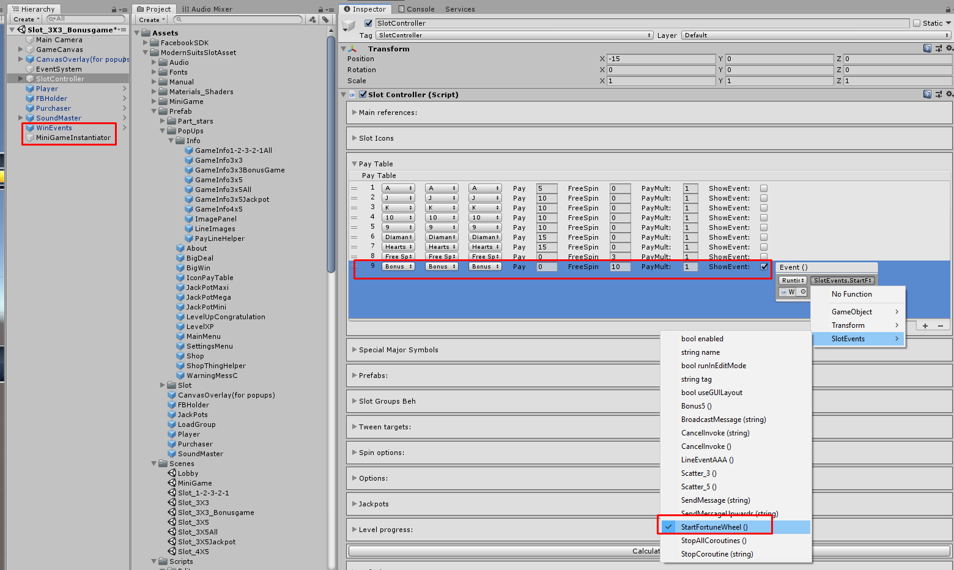

1. Check AutoStartMiniGame (optionally)

